Assignment Answers
Question 1
 |  | To
 |  | Kilkenny | Limerick | Mayo
From | Athlone | 4 | 8 | 6
From | Ballinasloe | 6 | 3 | 7
From | Cavan | 9 | 5 | 2

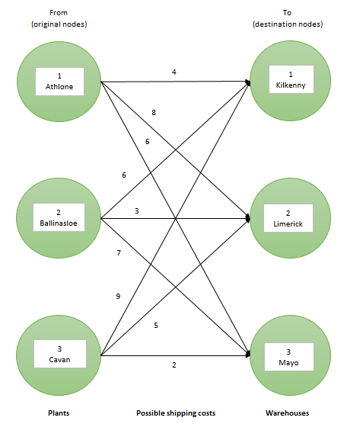
(ii) LINEAR PROGRAMING MODEL
 | a | X11 is the supply from Athlone to Kilkenny
 | b | X12 is the supply from Athlone to Limerick
 | c | X13 is the supply from Athlone to Mayo
 | d | X21 is the supply from Ballinasloe to Kilkenny
 | e | X22 is the supply from Ballinasloe to Limerick
 | f | X23 is the supply from Ballinasloe to Mayo
 | g | X31 is the supply from Cavan to Kilkenny
 | h | X32 is the supply from Cavan to Limerick
 | i | X33 is the supply from Cavan to Mayo
 | The objective is to minimize the daily total shipping cost. The shipping costs are;
 | Athlone: | 4X11 + 8X12 + 6X13
 | Ballinasloe: | 6X21 + 3X22 + 7X23
 | Cavan: | 9X31 + 5X32 + 2X33
 | The objective function: Minimise
 | Z = 4X11 + 8X12 + 6X13 + 6X21 + 3X22 + 7X23 + 9X31 + 5X32 + 2X33
 | Subject to:
 | X11 + X12 + X13 ≤ 120
 | X21 + X22 + X23 ≤ 80
 | X31 + X32 + X33 ≤ 20
 | X11 + X21 + X31 = 60
 | X12 + X22 + X33 = 120
 | X13 + X23 + X33 = 40
 | Xij ≥ 0, I = 1, 2, 3; j = 1, 2, 3

Question 2
 |  | To
 |  | Memphis | Denver | New York | Chicago | Los Angeles | Boston
From | Memphis | 0 | - | 8 | 13 | 25 | 28
From | Denver | - | 0 | 15 | 12 | 26 | 25
From | New York | - | - | 0 | 6 | 16 | 17
From | Chicago | - | - | 6 | 0 | 14 | 16
From | Los Angeles | - | - | - | - | 0 | -
From | Boston | - | - | - | - | - | 0

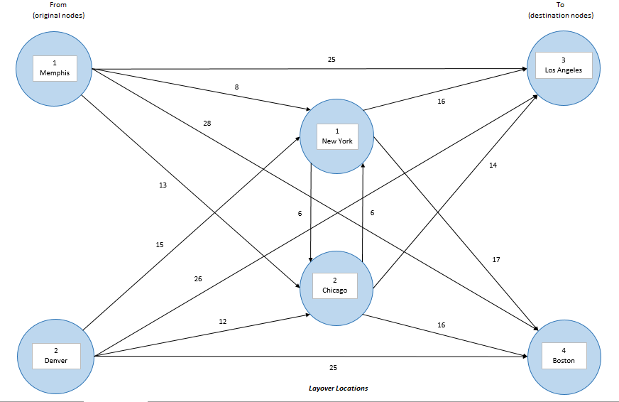

(ii) LINEAR PROGRAMING MODEL
 | a | X11 are the widgets delivered from Memphis direct to Los Angeles
 | b | X12 are the widgets delivered from Memphis through New York to Los Angeles
 | c | X13 are the widgets delivered from Memphis through Chicago to Los Angeles
 | d | X14 are the widgets delivered from Memphis through New York then Chicago and finally to Los Angeles
 | e | X15 are the widgets delivered from Memphis through Chicago then New York and finally to Los Angeles
 | f | X16 are the widgets delivered from Memphis direct to Boston
 | g | X17 are the widgets delivered from Memphis through New York to Boston
 | h | X18 are the widgets delivered from Memphis through Chicago to Boston
 | i | X19 are the widgets delivered from Memphis through New York then Chicago and finally to Boston
 | j | X20 are the widgets delivered from Memphis through Chicago then New York and finally to Boston
 | k | X21 are the widgets delivered from Denver direct to Los Angeles
 | l | X22 are the widgets delivered from Denver through New York to Los Angeles
 | m | X23 are the widgets delivered from Denver through Chicago to Los Angeles
 | n | X24 are the widgets delivered from Denver through New York then Chicago and finally to Los Angeles
 | o | X25 are the widgets delivered from Denver through Chicago then New York and finally to Los Angeles
 | p | X26 are the widgets delivered from Denver direct to Boston
 | q | X27 are the widgets delivered from Denver through New York to Boston
 | r | X28 are the widgets delivered from Denver through Chicago to Boston
 | s | X29 are the widgets delivered from Denver through New York then Chicago and finally to Boston
 | t | X30 are the widgets delivered from Denver through Chicago then New York and finally to Boston
 | The objective is to minimize the total transhipment costs. The transhipment costs are;
 | Memphis: | 25X11 + 24X12 + 27X13 + 28X14 + 35X15 + 28X16 + 25X17 + 29X18 + 30X19 + 36X20
 | Denver: | 26X21 + 31X22 + 26X23 + 35X24 + 34X25 + 25X26 + 32X27 + 28X28 + 37X29 + 32X30
 | The objective function: Minimise
 | Z = 25X11 + 24X12 + 27X13 + 28X14 + 35X15 + 28X16 + 25X17 + 29X18 + 30X19 + 36X20 + 26X21 + 31X22 + 26X23 + 35X24 + 34X25 + 25X26 + 32X27 + 28X28 + 37X29 + 32X30
 | Subject to:
 | X11 + X12 + X13 + X14 + X15 + X16 + X17 + X18 + X19 + X20 ≤ 150
 | X21 + X22 + X23 + X24 + X25 + X26 + X27 + X28 + X29 + X30 ≤ 120
 | X11 + X12 + X13 + X14 + X15 + X21 + X22 + X23 + X24 + X25 = 130
 | X16 + X17 + X18 + X19 + X20 + X26 + X27 + X28 + X29 + X30 = 130
 | Xij ≥ 0, I = 1, 2, 3 ; j = 0, 1, 2, 3, 4, 5, 6, 7, 8, 9

Question 3
 | Time (minutes)
 | Patient 1 | Patient 2 | Patient 3 | Patient 4
Machine 1 | 42 | 15 | 24 | 21
Machine 2 | 6 | 36 | 18 | 15
Machine 3 | 21 | 24 | 9 | 27
Machine 4 | 6 | 12 | 18 | 30

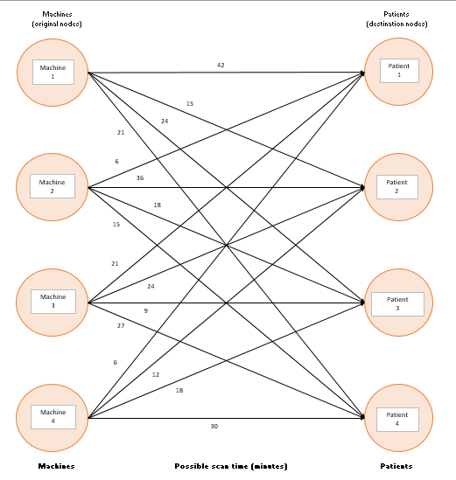
(ii) LINEAR PROGRAMING MODEL
 | a | X11 is the scan by Machine 1 to Patient 1
 | b | X12 is the scan by Machine 1 to Patient 2
 | c | X13 is the scan by Machine 1 to Patient 3
 | d | X14 is the scan by Machine 1 to Patient 4
 | e | X21 is the scan by Machine 2 to Patient 1
 | f | X22 is the scan by Machine 2 to Patient 2
 | g | X23 is the scan by Machine 2 to Patient 3
 | h | X24 is the scan by Machine 2 to Patient 4
 | i | X31 is the scan by Machine 3 to Patient 1
 | j | X32 is the scan by Machine 3 to Patient 2
 | k | X33 is the scan by Machine 3 to Patient 3
 | l | X34 is the scan by Machine 3 to Patient 4
 | m | X41 is the scan by Machine 4 to Patient 1
 | n | X42 is the scan by Machine 4 to Patient 2
 | o | X43 is the scan by Machine 4 to Patient 3
 | p | X44 is the scan by Machine 4 to Patient 4
 | The objective is to minimize the time required to scan the patients by each machine. The time in minutes is show below;
 | Machine 1: | 42X11 + 15X12 + 24X13 + 21X14
 | Machine 2: | 6X21 + 36X22 + 18X23 + 15X24
 | Machine 3: | 21X31 + 24X32 + 9X33 + 27X34
 | Machine 4: | 6X41 + 12X42 + 18X43 + 30X44
 | The objective function: Minimise
 | Z = 42X11 + 15X12 + 24X13 + 21X14 + 6X21 + 36X22 + 18X23 + 15X24 + 21X31 + 24X32 + 9X33 + 27X34 + 6X41 + 12X42 + 18X43 + 30X44
 | Subject to:
 | X11 + X12 + X13 + X14 = 1
 | X21 + X22 + X23 + X24 = 1
 | X31 + X32 + X33 + X34 = 1
 | X41 + X42 + X43 + X44 = 1
 | X11 + X21 + X31 + X41 = 1
 | X12 + X22 + X32 + X42 = 1
 | X13 + X23 + X33 + X43 = 1
 | X14 + X24 + X34 + X44 = 1
 | Xij ≥ 0, I = 1, 2, 3, 4; j = 1, 2, 3, 4

